E-Commerce Platform Architecture for High-Traffic Events: A Technical Deep Dive

Prepared for: Emily Watson, IT Technical Lead
Prepared by: Anoop Korappath
Date: April 17, 2025
Subject: Detailed Architecture Report for the New E-Commerce Platform Supporting High-Traffic Events

Contents

1.0 Executive Summary 2
2.0 Introduction 2
3.0 Functional and Non-Functional Requirements 2
4.0 Systems and Subsystems Architecture with Diagrams 4
5.0 Information Exchange Characteristics 7
6.0 Potential Failure Points 8
7.0 Mitigation Actions for Failure Prevention 9
8.0 System Behaviour Under Varying Load Conditions 9
9.0 Architectural Considerations for Cost Implications 10
10.0 Contingency Plans for Failure Scenarios 10
11.0 Conclusion 10

1.0 Executive Summary
This report details the architectural design of a new e-commerce platform specifically engineered to support high-traffic events, exemplified by Black Friday. It outlines the necessary systems and subsystems, the nature of information exchange, potential failure points, mitigation strategies, contingency plans, the system's dynamic behaviour under varying load conditions, and the architectural considerations driven by cost implications. This document aims to provide a comprehensive technical understanding of the platform's design and its ability to meet stringent functional and non-functional requirements.

2.0 Introduction
The objective is to establish a resilient, scalable, and performant e-commerce platform capable of handling the extreme demands associated with high-traffic events such as Black Friday. This report addresses the architectural considerations for meeting the specified customer requirements, including anticipated user volumes, transaction rates, platform support, and critical functional and non-functional needs. The subsequent sections provide a detailed breakdown of the platform's architecture and its key characteristics.

3.0 Functional and Non-Functional Requirements
The platform is designed to meet the following key requirements:
- 3.1 Functional Requirements:
  - Secure User Authentication: Implementation of Single Sign-On (SSO) for user convenience and Multi-Factor Authentication (MFA) for enhanced security during login processes.
  - Product Catalogue, Shopping Cart, and Checkout: Comprehensive functionality for browsing and searching products, managing user selections in a shopping cart, and a streamlined checkout process leading to order placement.
  - Multiple Payment Gateway Integrations with Failover: Integration with a range of payment gateways prevalent within the target market, including a robust failover mechanism to ensure transaction continuity in case of a primary gateway issue. The payment gateways must support most banks within the country.
  - Order Tracking, Notifications, and User Reviews: Systems for users to track their order status from placement to delivery, timely notifications regarding order updates, and the ability for users to submit and view product reviews.
  - Admin Dashboard with Analytics and Role-Based Access: A secure administrative interface providing dashboards for system monitoring, key performance indicators (KPIs), comprehensive analytics, and role-based access control for different administrative functions.
- 3.2 Non-Functional Requirements:
- High Availability (99.99% Uptime): The platform must ensure 99.99% uptime, even during peak traffic periods, to maintain continuous service availability.
- Scalability with Auto-Scaling: The system must automatically scale its resources (e.g., compute, storage) to handle the significant increase in load during peak events like Black Friday, ensuring performance is maintained.
- Performance (API Response Time < 200ms): Critical API endpoints must have a response time of less than 200 milliseconds to provide a smooth and responsive user experience.
- High Payment Success Rate (> 98%): The system must maintain a payment success rate exceeding 98% to ensure a seamless checkout experience and minimise lost revenue.
- Compliance (PCI DSS, GDPR, CCPA): The platform must adhere to relevant data security and privacy regulations, including PCI DSS for payment card information, GDPR for European user data, and CCPA for California user data (given the potential for international replication).
- Real-Time Monitoring and Graceful Degradation: Implementation of real-time monitoring tools to track system health and performance, coupled with graceful degradation strategies to maintain core functionality even in the event of partial system failures.

4.0 Systems and Subsystems Architecture with Diagrams
The platform architecture comprises several key systems and subsystems, as illustrated in the following diagrams:
- 4.1 High-Level System Diagram:
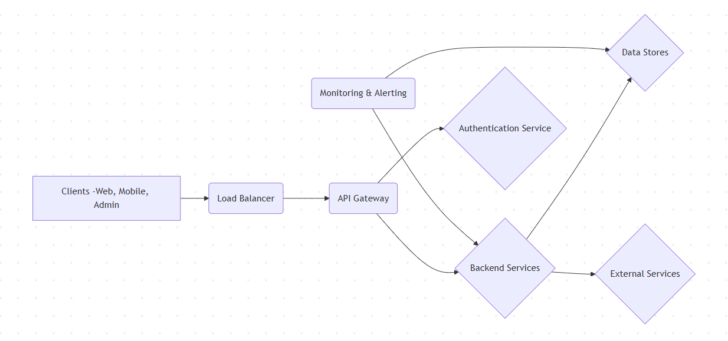
- 4.2 Backend Services Subsystem:
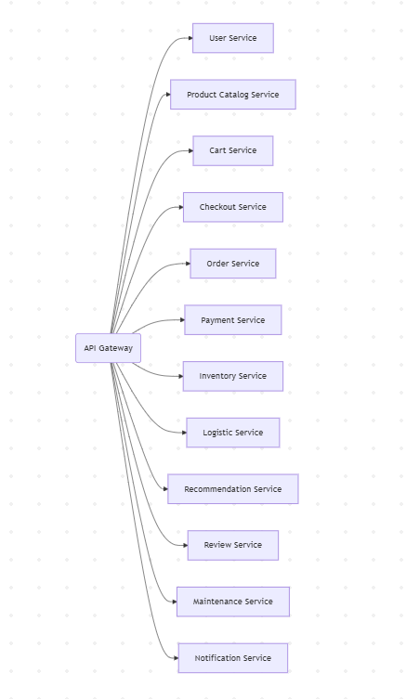
- 4.3 Data Stores Subsystem:
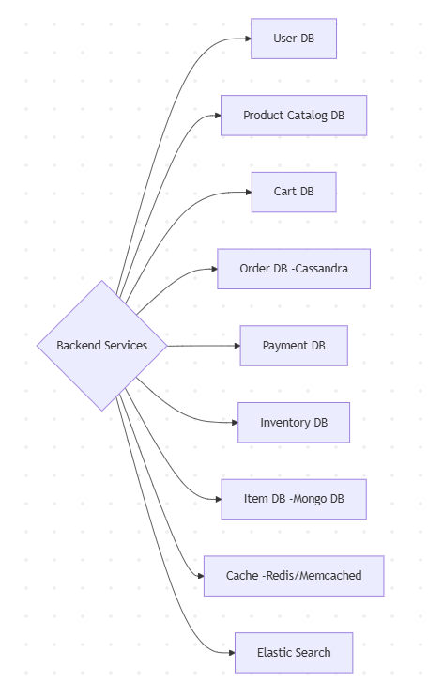
Detailed Description of Systems and Subsystems:
- 4.4 Client Systems: Provide the user interface across various platforms. Secure communication is paramount, with mobile clients also employing enhanced authentication mechanisms.
- 4.5 API Gateway: Acts as the single point of entry, managing traffic and routing requests to the appropriate backend services. Load balancing ensures scalability and availability.
- 4.6 Backend Services: A suite of microservices responsible for specific business functionalities. Each service interacts with relevant data stores and potentially other services.
  - User Service: Manages user-related data and authentication.
  - Product Catalog Service: Handles product information and search.
  - Cart Service: Manages user shopping carts.
  - Checkout Service: Orchestrates the payment and order initiation process.
  - Order Service: Manages the order lifecycle.
  - Payment Service: Integrates with payment gateways.
  - Inventory Service: Tracks stock levels.
  - Logistic Service: Manages shipping and delivery.
  - Recommendation Service: Provides product suggestions.
  - Review Service: Manages product reviews.
  - Maintenance Service: Supports administrative tasks.
  - Notification Service: Handles user communications.
- 4.7 Data Stores: A combination of relational and NoSQL databases, along with caching and search technologies, chosen for their specific strengths in handling different types and volumes of data.
- 4.8 Authentication Service: (Implicit in the Backend Services diagram) A dedicated service responsible for handling user authentication, including SSO and MFA, ensuring secure access to the platform.
- 4.9 External Services: Integrations with third-party systems such as payment gateways and logistic providers.
- 4.10 Monitoring & Alerting: A critical system for tracking performance, identifying issues, and providing alerts to operations teams.

5.0 Information Exchange Characteristics
The exchange of information within the platform varies significantly in frequency, speed (latency/throughput), and volume depending on the specific interaction:
- 5.1 Client Systems <-> API Gateway: High frequency, low latency (critical for user experience), high volume (especially read requests for product data).
- 5.2 API Gateway <-> Backend Services: Moderate to high frequency, low latency (important for service orchestration), moderate volume (structured data).
- 5.3 Backend Services <-> Data Stores: High frequency (reads), moderate frequency (writes), high throughput (database access), high volume (product data retrieval, order data storage).
- 5.4 Specific Service Interactions:
  - Checkout Service <-> Payment Service: Moderate frequency, low latency (critical for transaction success), low volume per transaction (high aggregate).
  - Order Service <-> Inventory Service (via Message Queue): Moderate to high frequency, asynchronous (timely processing), low volume per event (high aggregate).
  - Order Service <-> Logistic Service: Moderate frequency, moderate latency, low volume per order (significant aggregate).
  - Product Catalog Service <-> Cache: Very high frequency (reads), moderate frequency (writes), very low latency (critical for performance), variable volume.
  - Product Catalog Service <-> Elastic Search: Lower frequency (indexing, high volume), high frequency (searching, moderate volume), low latency (search).
  - Monitoring Systems <-> Platform Components: Continuous frequency, near real-time speed (metrics), high volume (aggregated logs and metrics).

6.0 Potential Failure Points
A thorough risk assessment has identified the following potential failure points within the system:
- Infrastructure failures (servers, network, load balancers).
- Application-level errors (code defects, resource exhaustion).
- Data store failures (database outages, data corruption, cache invalidation issues, search engine unavailability).
- Third-party service disruptions (payment gateways, CDN, external data sources).
- Security breaches (data exfiltration, denial-of-service attacks).
- Scalability limitations under extreme load.
- Deployment and configuration errors.

7.0 Mitigation Actions for Failure Prevention
To proactively address the identified failure points and ensure high availability, the following mitigation strategies are being implemented:
- Implementing redundancy across all critical infrastructure components and services.
- Deploying robust auto-scaling mechanisms to handle fluctuating traffic.
- Utilising aggressive caching strategies to minimise load on backend systems.
- Employing database replication and automated failover procedures.
- Implementing circuit breaker patterns and retry mechanisms for inter-service communication.
- Establishing comprehensive monitoring and alerting systems with proactive thresholds.
- Conducting rigorous load and performance testing under simulated peak conditions.
- Adhering to secure coding practices and implementing robust security measures.
- Utilising Infrastructure as Code (IaC) and automated deployment pipelines to minimise configuration errors.

8.0 System Behaviour Under Varying Load Conditions
The system is designed to exhibit different behaviours under average and peak load:
- Average Load: Characterised by normal resource utilisation, optimal response times, and full feature availability. Background processes can operate without impacting user experience, and deployments can occur more frequently.
- Peak Load: Requires aggressive auto-scaling to manage increased traffic. Prioritisation of core functionalities (browsing, checkout) becomes critical, potentially with temporary throttling or disabling of non-essential features. Caching layers become paramount, and robust error handling and rate limiting are essential to maintain stability. Monitoring and incident response become highly critical.

9.0 Architectural Considerations for Cost Implications
Recognising the importance of cost efficiency, the architecture incorporates the following considerations:
- Leveraging the elasticity and pay-as-you-go models of cloud providers.
- Strategic use of serverless technologies for suitable workloads.
- Implementing multi-layered caching to reduce infrastructure costs associated with backend processing and database access.
- Selecting right-sized and cost-effective database solutions based on specific data requirements.
- Optimising auto-scaling configurations to avoid over-provisioning during off-peak times.
- Employing cost management tools for continuous monitoring and optimisation of cloud expenditure.

10.0 Contingency Plans for Failure Scenarios
In the event of system failures, the following contingency plans will be activated:
- Automated failover mechanisms for critical services and databases.
- Well-defined and regularly tested disaster recovery procedures.
- Rapid rollback capabilities for problematic deployments.
- A dedicated incident response team with clear communication protocols.
- Implementation of graceful degradation strategies to maintain core functionality.
- Automated alerts to promptly identify and escalate issues.
- Utilisation of secondary payment gateway integrations in case of primary provider issues.

11.0 Conclusion
The architecture of our new e-commerce platform has been meticulously designed to meet the demanding requirements of high-traffic events like Black Friday. By implementing a robust and scalable infrastructure, proactive failure prevention measures, and adaptive behaviour under varying load conditions, we aim to provide a resilient and seamless user experience. Furthermore, cost efficiency has been a key consideration throughout the design process. This detailed overview provides the necessary technical context for the continued development and successful deployment of this critical platform.

